Willy Tardif

INFO 3401

**CU Gym**

From the data that was recently acquired by CU about how there’s a positive correlation between going to the gym and a higher GPA, I have been tasked with coming up with a plan to get more students to go to the gym more often. I was given three datasets which give me insights into the current use of the gym and how many students are using it. These datasets provided a good amount of information that allowed me to make connections and make predictions on what I think would work and what wouldn’t work. Although these datasets contained a lot of valuable information, the three aspects I decided to focus on first was; how many students go to the gym each day, what hours of the day do they go, and what days they go.

The first thing I noticed was that, in the “day_of_week” section, there only four days of data that are given to us; day 1, 5, 6, and 7. I believe this means the days that were studied were Monday, Friday, Saturday, and Sunday. With this information, I decided to make graphs based on the four days (labeled day 1, day 5, day 6, and day 7). I tried to see if there was any relation to the hour of the day people go to the gym and the number of students in the gym. My initial prediction was that the peak of the most people in the gym would be at around 5 o’clock in the afternoon and the slowly decline till the gym closes. I also predicted that the peak would differ from day to day (not a lot but enough to notice a difference). These are the graphs I made:

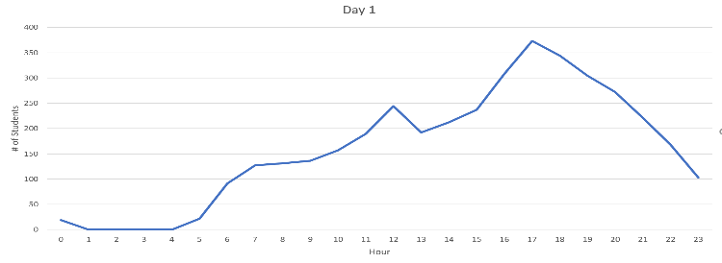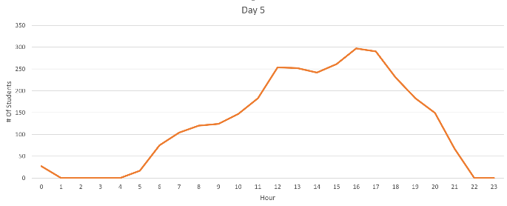

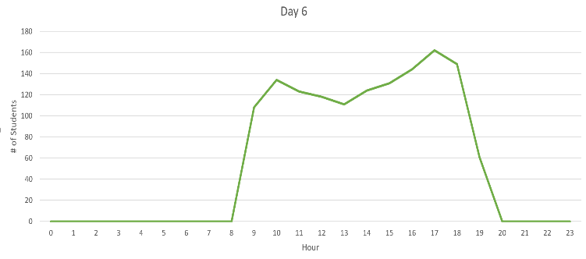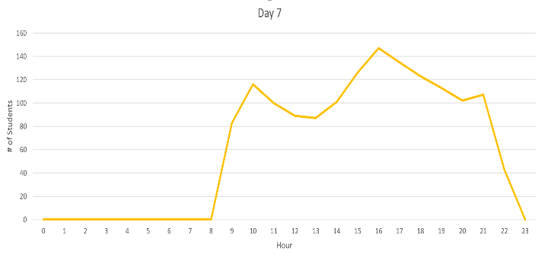

Based on these graphs, my initial predictions were pretty accurate. A majority of students go to the gym around 5 o’clock each day (studied). The reason why I believe it is this way is because students want to work out or be athletic prior to eating dinner. This allows them to exert all their energy they’ve been holding in during classes and then recover right after by eating dinner. Even though it’s good to know that a majority of the students go to the gym at around 5, we want to get more students there. To do this, I believe we should try to get students to go to the gym during the academic day (before 3). My reasoning for this is, due t the fat that many students go to the gym at 5, I want to try and avoid that time and convince students to go at different times. This would make the gym less crowded and, in turn, might make students feel more comfortable while working out. The two proposals I came up with were;

1: Hold more gym events during the academic day. Whether this be a game to a weight lifting activity, if we can get more students motivated to go to the gym in between classes or right as they finish classes, then it would disperse some of the crowd that forms at around 5 o’clock. This would also allow the students to let go of the stress of school work quicker and allow them to be more relaxed.

2: Have some sort of weight lifting club for all weight ranges / lifting abilities. By being part of a group, this would encourage students to motivate each other to go to the gym, as well as allow them to push each other more while working out. This club could break the students up at the beginning of the year and assign them times (when everyone in the group is free) to go to the gym and have an hour to two-hour long workout session.

To make sure these plans both go into action and work, I would, for the first plan, hire a group of people who would organize and plan events at the gym throughout the year. This group can be all college students (which we could pay around 9-10 dollars an hour) or can be outsiders who have no relation to the school (which we can pay based on the events they held). I would also have them collect data that would, one; tell me how many people showed up to each event and if there are any returners (this would be easy to tell with your Buff One card), two; record what event they did on that day and how many people showed up, and three; based on the first data set collected (see who returned to the events), see if their GPA has gone up, stayed even, or dropped. For the second plan, I would hire one to two instructors (Who I would pay around 20 per hour) who may or may not already be affiliated with CU and have them keep track of, one; how many people are part of the club, two; keep track of the groups who formed and assign them time during the week they go and workout, three; provide each student with a workout plan (based on their weight and lifting ability) and four; collect data on the progress each student is making along with their GPA and see if there is any correlation.

These proposals aren’t anything too intense, but I believe would have a very positive affect on the student body along with seeing if the students GPA has changed at all during the time the events or club has been taking place.